File Management
1. Script – this command will record the script input and output
script -a my_terminal.log
# Run your commands here
Exit
2. vi /vim/nano – these are editors , used to edit text files
vi filename
I – for inserting /editing
Esc – for exiting editing mode
:wq – exiting the vi editors with save the changes

File Permission
drwxrwxr-x
d – directory
r- read , w – write , x -execute
rwx – first three char reperesnt user access
rwx – represents group access
r-x - represent others
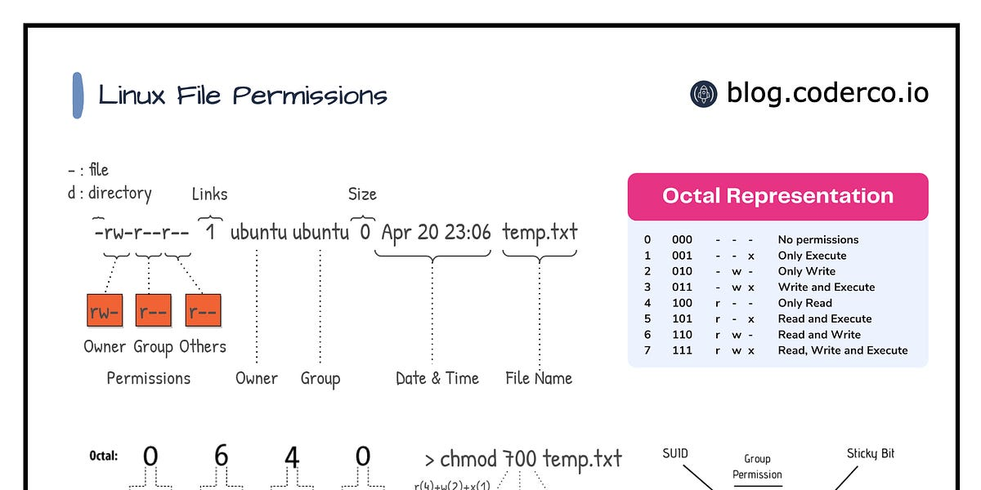

- chmod - to modify file permission

chmod octal_code filename

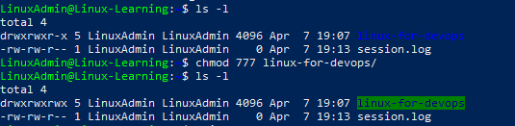

- umask – default file permission
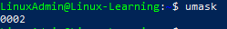

- chown – to change owner of file/folder

- gkjk

